Choosing Your Child’s First Computer
Are you wondering if it's time to buy your five-year-old a computer? If you've been noticing more and more cartoons and coloring games on your work-assigned laptop or desktop monitor lately, now would be a good time to get your child's first computer. But, is this move right for her, and is she old enough? Yes, absolutely!

Did you know that in the year 2013 alone, around 79% of kids were using their home computers? Further, kids aged 3 to 17 years or 6 out of 10 kids were adept at using digital devices including mobile phones and tablets. By the first or second grades, when kids are already using computers in school, it's a good idea for her to have one at home so she can learn while playing games and other child-friendly activities.

Whether or not to buy your child’s first computer is an easy decision. But, as a parent, you need to put a lot of thought into the right device to buy. Here are some basic considerations you must keep in mind.

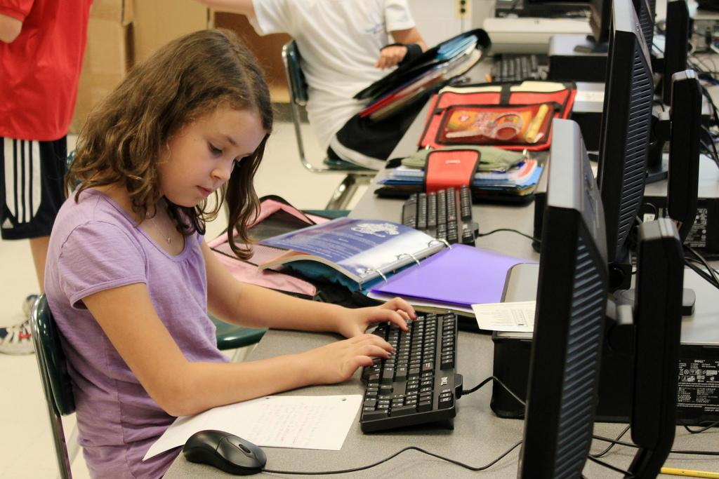

Get a Family Computer
As your kids grow older, they're going to need a computer for homework as well playing games. Choose a device that you can set up in the family living room where you can supervise the kids' activities. Given that they can inadvertently stumble on inappropriate YouTube clips, videos, and other material, you'll want to keep a careful watch on what the kids are doing. Some parents also prefer a laptop computer so that they can put it away when they're not present to watch their kids. Not only can you find affordable laptops, but choosing a refurbished device as your child’s first computer can bring your costs down.

Check for the Latest Software
Even if the refurbished computer is a bit worn down, your kids are going to be so thrilled at the prospect of having one; they won't notice it. However, you must make sure that it has the latest software. Such software installed in the newest operating systems give you the most advanced of parental controls. You can also verify that the computer has all the security measures that can protect you and the family from phishing and other threats. Create folders that have your child's favorite games and websites that you've approved. They'll find accessing them so easy that they won't feel the need to surf and search. Limiting internet access is another strategy you can use to protect your kids.

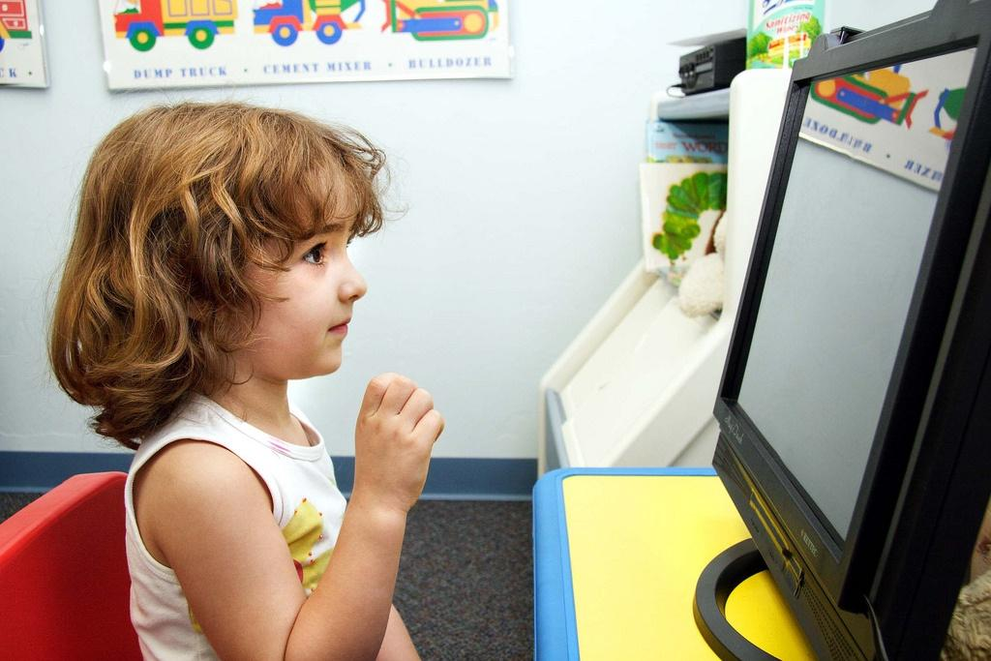

Get Your Child Her Account
When buying your child’s first computer, look for one that supports Windows 10 so you can set up an individual account for your child. Create an account on account.microsoft.com/family with the appropriate age restrictions and also fix time limits. You'll also be able to restrict the websites your child can visit and allow her to play only those games and use apps that are appropriate for her. Getting a Microsoft account that is an extension of the family has another advantage. Your child can use it to sign into any other device aside from the computer and the settings you've set will apply to the device. Every week, you'll receive an email informing you of the websites your child has visited, the time she spent on each, and the total time she spends on the computer.

Added Accessories
You’re going to need a bunch of accessories for your child's first computer. These can include software that can charge the child's first computer quickly. Look for other add-ons like a new storage device or a RAM memory upgrade along with a new battery, and you're good to go. Lowering the loading times will ensure that your child spends the minimum amount of time on the computer. Give her creativity an added boost with the help of DVD or CD burning device, scanner, and digital camera.

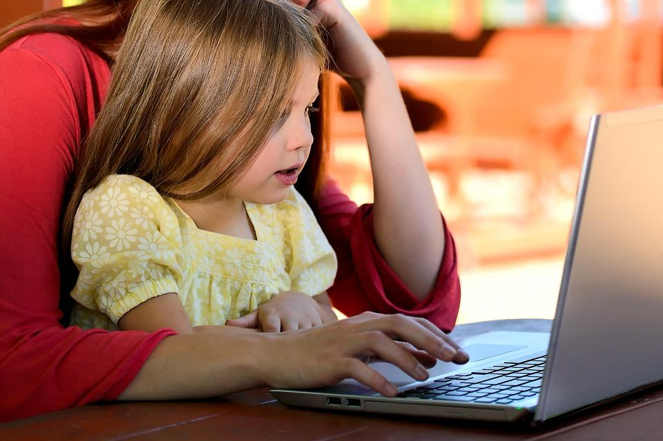

Should You Opt for a Refurbished Computer
Buying your kids an inexpensive, refurbished computer is a wise choice. You can ensure that in case they have spills and accidents and cause significant damage to the CPU or keyboard, it's not a major loss. Look for a manufacturer-sourced refurbished device as your child’s first computer. Such products are sold after strict quality control measures and extensive checking. Look for a recently released device as your child's first computer, and you might be able to find one that is practically new or hasn't been used at all. It could last her a good long while.

The Right Time to Buy a Computer
In an increasingly tech-savvy world, digital literacy has become very essential. You’ll want to expose your child to various devices so she can adapt and learn to deal with them in a professional setting later in life. However, it is also understandable that you're concerned about the right age for exposure and if this move is good for her. Given the rising number of cases of obesity among children, you'll want to ensure that she does not spend too much time indoors glued to the computer. At the same time, giving her access to additional study material is an advantage you'll want to make available to her.

When making your decision, assess how mature your child is and if her psyche is developed enough to manage devices. As a parent, you’re the best judge of whether or not it’s time to choose your child’s first computer and the perfect device for her.

